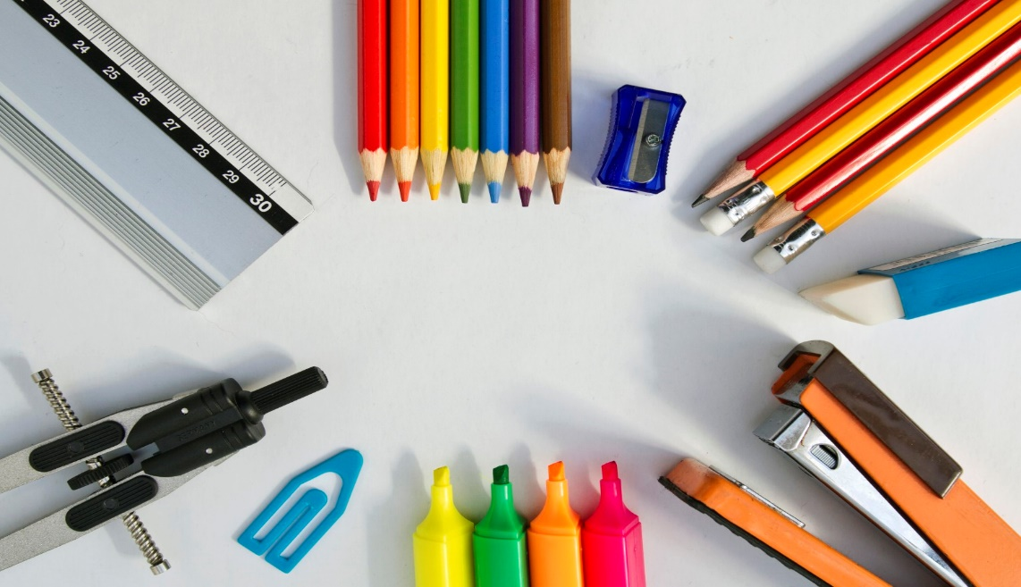

**GENERAL**

pencils (mechanical or regular)

dry erase markERS (3 OR MORE)

highlighters: yELLOW, BLUE, PINK, MORE IF DESIRED

COLORED PENCILS OR MARKERS

CLOROX WIPES (2 containers)

BOX OF KLEENEX (2 boxes)

SCISSORS

EARBUDS/HEADPHONES FOR COMPUTERS

FLASH DRIVE

*No zip-up binders (these are Not needed)

**Oasis 7th Grade**

**Supply List**

**SCIENCE**

3-SUBJECT SPIRAL NOTEBOOK

Small bottle of white school glue

**ELA**

ERASABLE pENS (BLUE/BLACK)

2 COMPOSITION BOOKS

A 2-POCKET FOLDER

INDEX CARDS

POST-ITS

**SOCIAL STUDIES**

1” 3-RING BINDER WITH 5 DIVIDERS

**MATH**

Scientific calculator (the school uses the casio fx-55 plus, it’s blue)

1 ½ “ 3-ring binder (for math only)

red pens

sheet protectors (~25-30)

1 pkg of lined paper (wide ruled)

ruler